Military Institute of Science and Technology
Department of Electrical Electronic and Communication Engineering
EECE – 222: Electrical Service Design & CAD Laboratory

Course Code: EECE-222

Project Report
Group-A9
Topic- Auditorium Floor Plan & Electrical lines with proper calculation

Name | ID
Md. Raisul Islam Ratul | 202216049
Md. Rakibul Hasan | 202216051
Md. Sadman-A-Rahman | 202216053

Date of Submission | December 2,2023



Index
Sl. No | Topic | Page No
1 | Introduction | 1
2 | Figures  - Figure 1 – Floorplan  - Figure 2 – Floor plan with all fittings and fixtures  - Figure 3 – Conduit layout  - Figure 4 – SLD
3 | Calculation
4 | Estimation of Total Cost
5 | Conclusion
6 | Reference

Auditorium Floor Plan & Electrical lines with proper calculation

Abstract
This document presents a formal description of the architectural design assigned, specifically an Auditorium. Auditoriums serve as pivotal spaces for hosting diverse events, performances, lectures, and gatherings.

Introduction
The focus of this architectural assignment is an Auditorium. These spaces are integral components within infrastructures, facilitating a wide array of events and presentations. They are meticulously designed to ensure optimal comfort and functionality for both audience members and presenters alike.

Floor Plan Description

The floor plan of the auditorium embodies a structured layout that harmonizes with its intended functionalities:

1. Main Hall: The central area of the auditorium where audience seating is strategically arranged to optimize visibility and acoustics. The seating configuration is tailored to provide a clear line of sight to the stage or presentation area, ensuring an engaging experience for attendees.
2. Stage Area: Positioned as a focal point, the stage is equipped with sophisticated lighting, sound systems, and customizable backdrops, catering to diverse event requirements. The stage dimensions accommodate speakers, performers, or presenters, offering ample space and amenities for effective content delivery.
3. Technical Booths & Media Center: Dedicated spaces housing technical equipment such as lighting controls, sound systems, projectors, and AV gear. These booths are strategically positioned to facilitate seamless operations during events, ensuring optimal technical support.
4. Access Ways: Emphasis is placed on well-designed entrances/exits, aisles, and pathways to ensure smooth audience and staff navigation during events. Safety and accessibility standards are rigorously adhered to within the design layout.

Assignment Details
The floor plan of this Auditorium spans an area of 5000 square feet, offering versatility in accommodating moderate to large audiences. This space is amenable to various seating configurations, ensuring a comfortable and engaging experience for attendees across a spectrum of events and presentations.
Our auditorium is basically divided in four segments:
- Main Hall
- Stage Area
- Back Stage
- General Discussion and Entrance
Length = 114 ft. 4 inches
Width= 42 ft. 3 inches
The Main Hall, with its dimensions of 39 feet in width and 43 feet in length, stands as the primary space dedicated to accommodating auditorium seating within our single-story establishment. The provision of an optimal mounting height for superior lighting is pivotal to enhance visibility and create a conducive environment for various events and presentations.

Within the backstage area, our focus remains on providing ample room and clarity to ensure the comfort and convenience of artists and performers. It's imperative that this space is adequately sized not only for their comfort but also to house an efficient air conditioning system, catering to the varying needs of different performances and events.

Moreover, the design emphasizes a spacious and accessible general discussion area that serves as a hub for all attendees. This space is envisioned to foster meaningful interactions and engagement among participants, creating an inclusive environment that encourages dialogue and collaboration.

Additionally, the entrance is designed to be well-lit and spacious, creating a welcoming ambiance that sets the tone for the overall auditorium experience. Its ample space aims to accommodate the flow of visitors seamlessly, ensuring a smooth and pleasant entry into the premises.
Figures:
Figure 1 – Floorplan
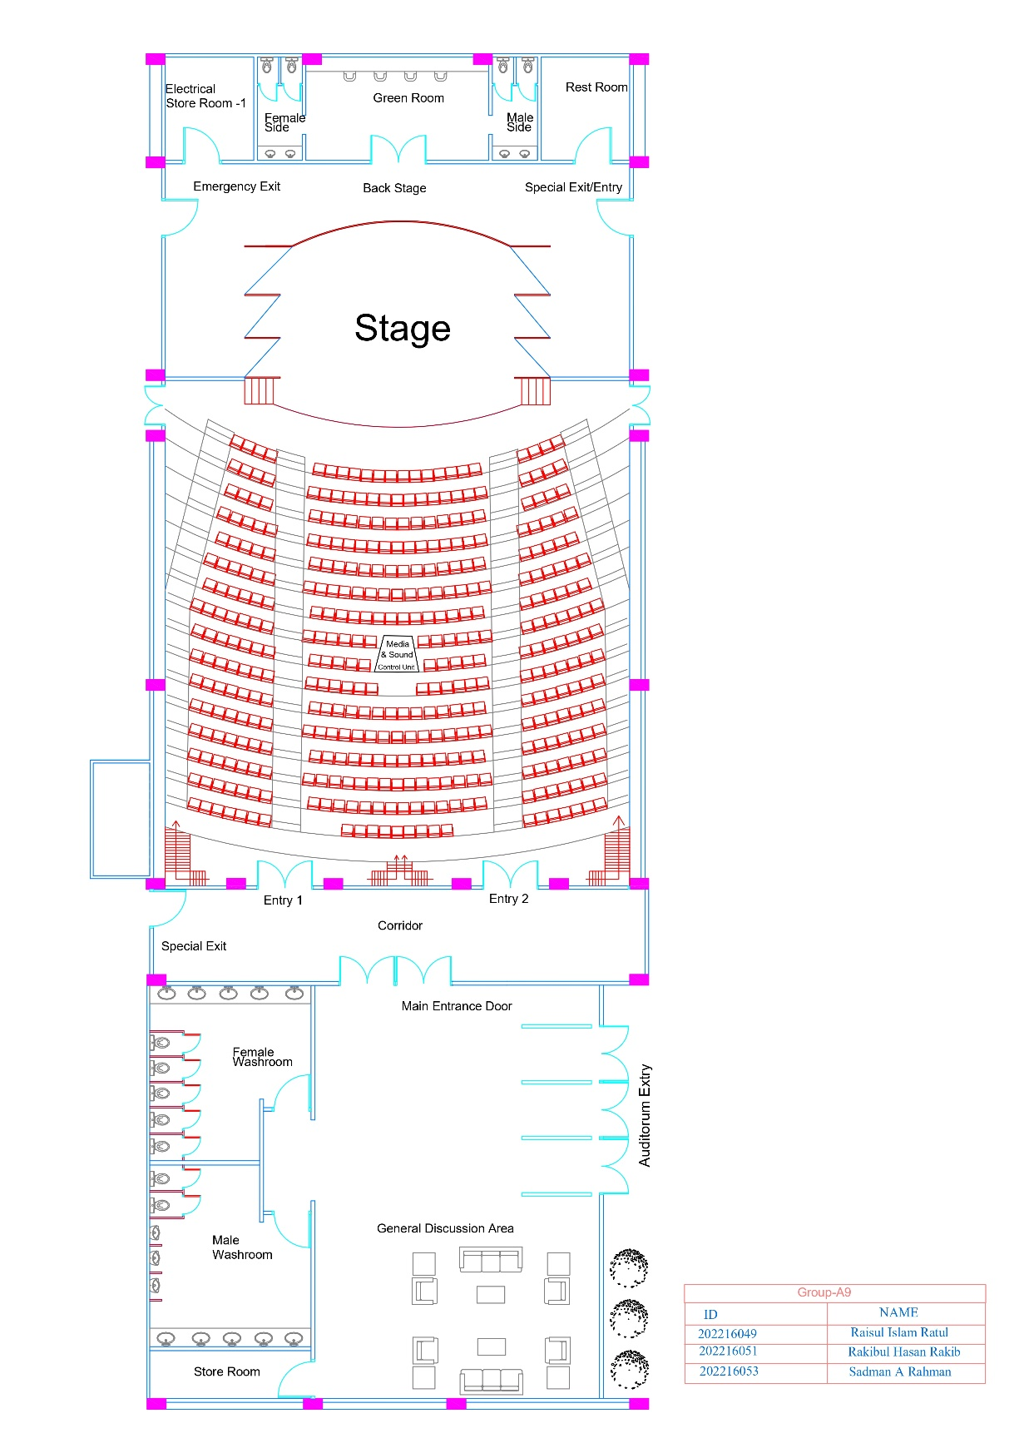
Figure 1– Floor plan
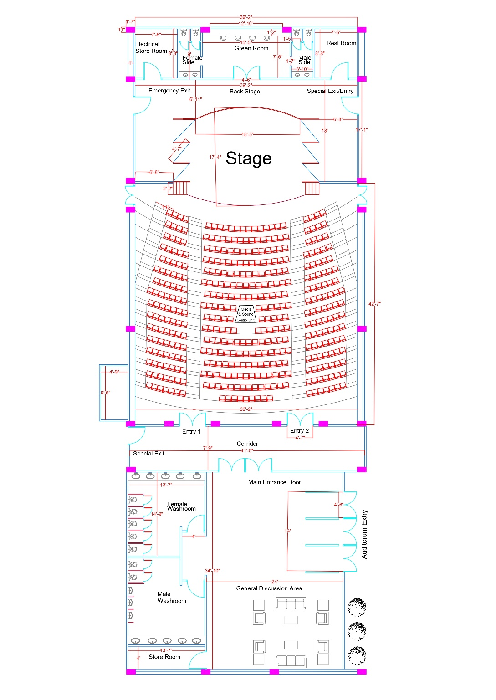
Figure 2 Floor Plan with Dimension

Figure 2 – Floor plan with all fittings and fixtures placed in appropriate position

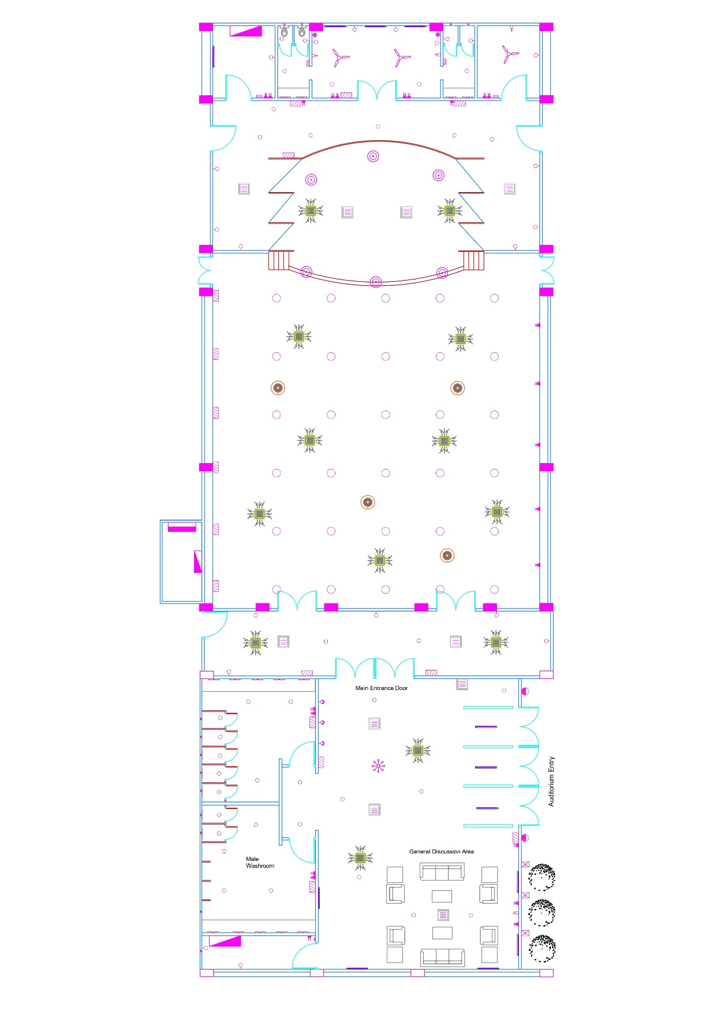
Figure 3 Fitting -Fixture
Figure 3 – Conduit layout
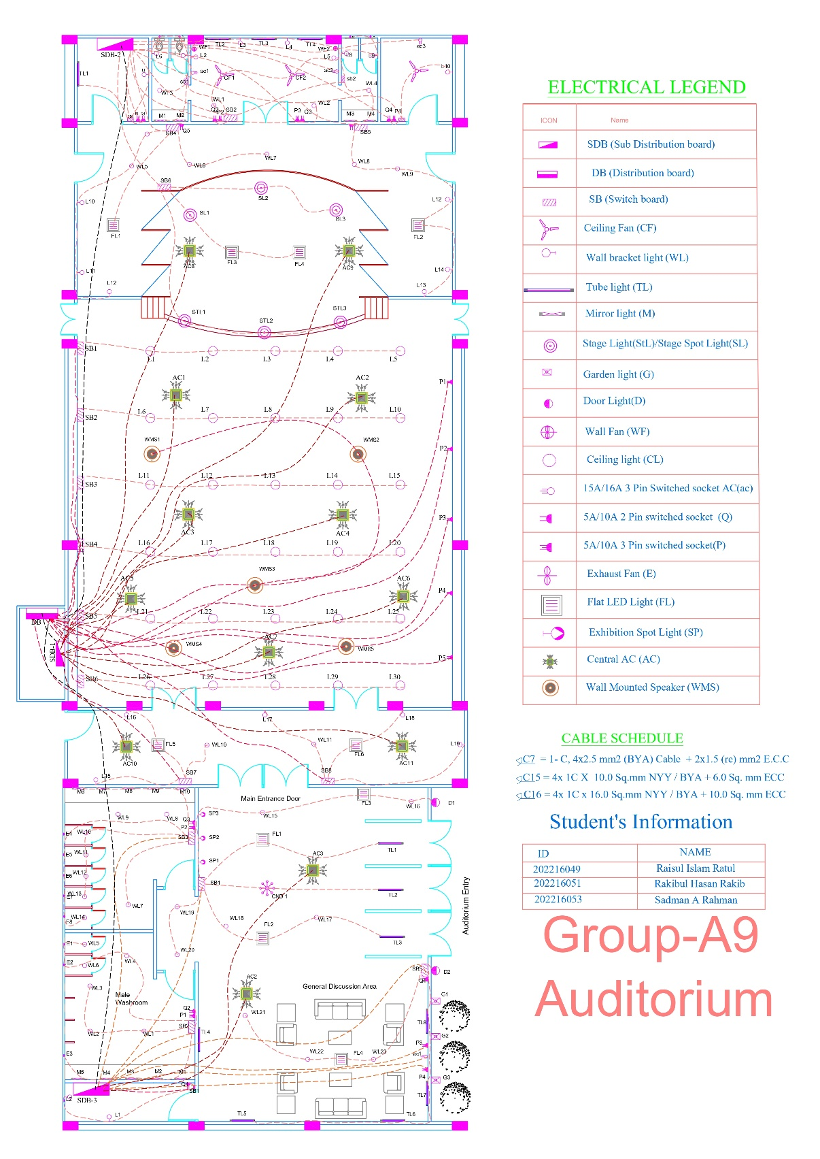
Figure 4 Conduit Layout

Figure 4 – SLD

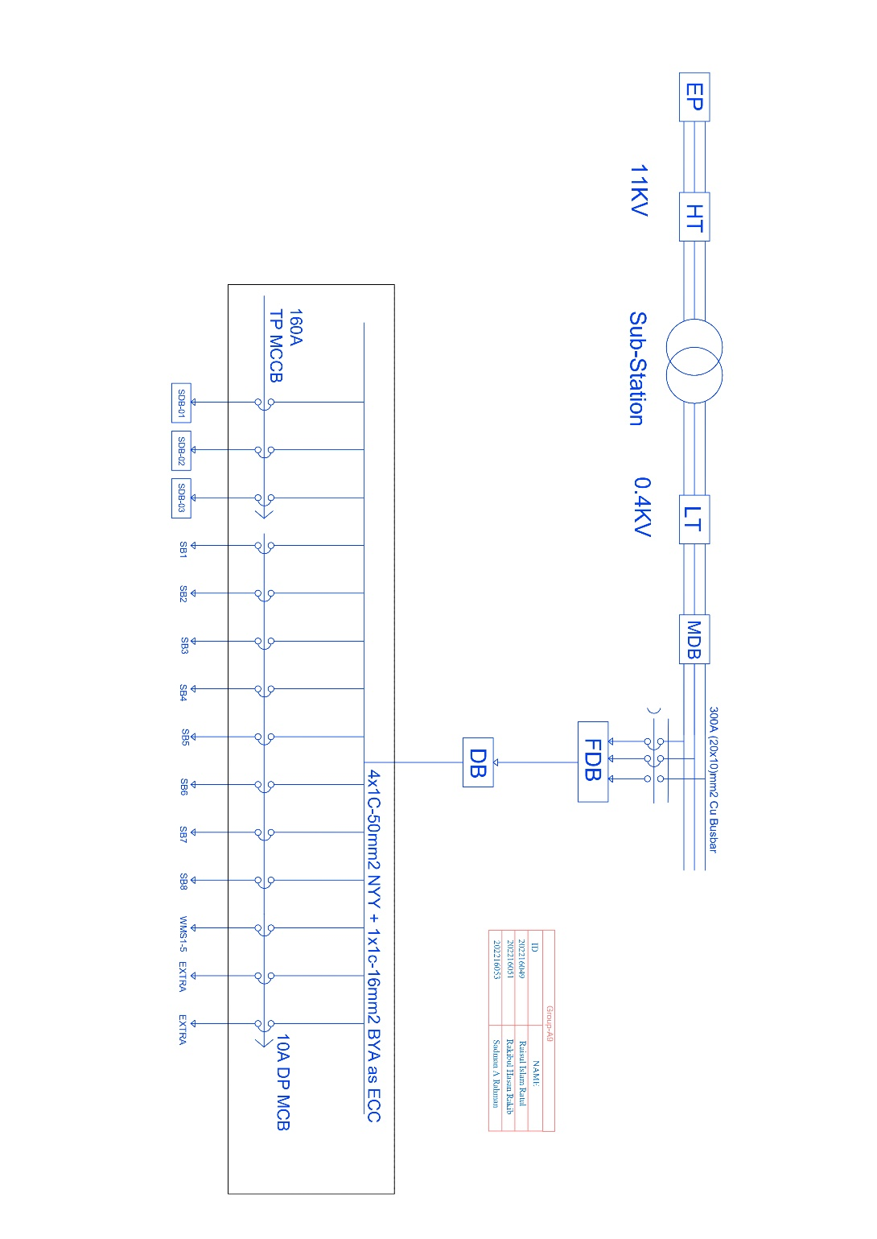
Figure 5 Substation to DB

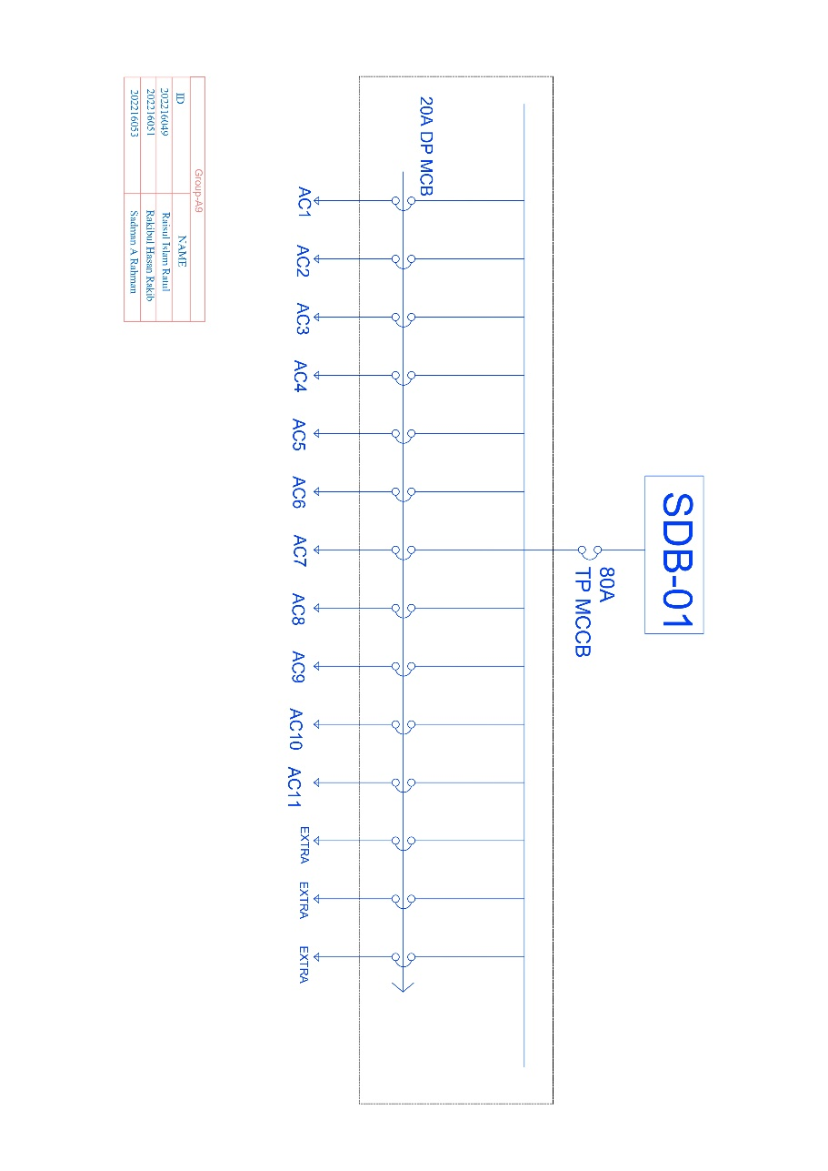
Figure 6 SDB1

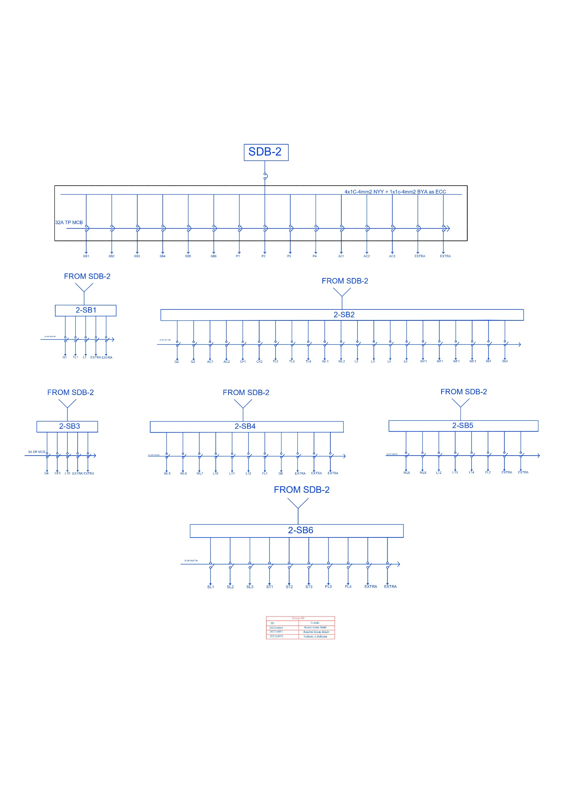
Figure 7 SDB2

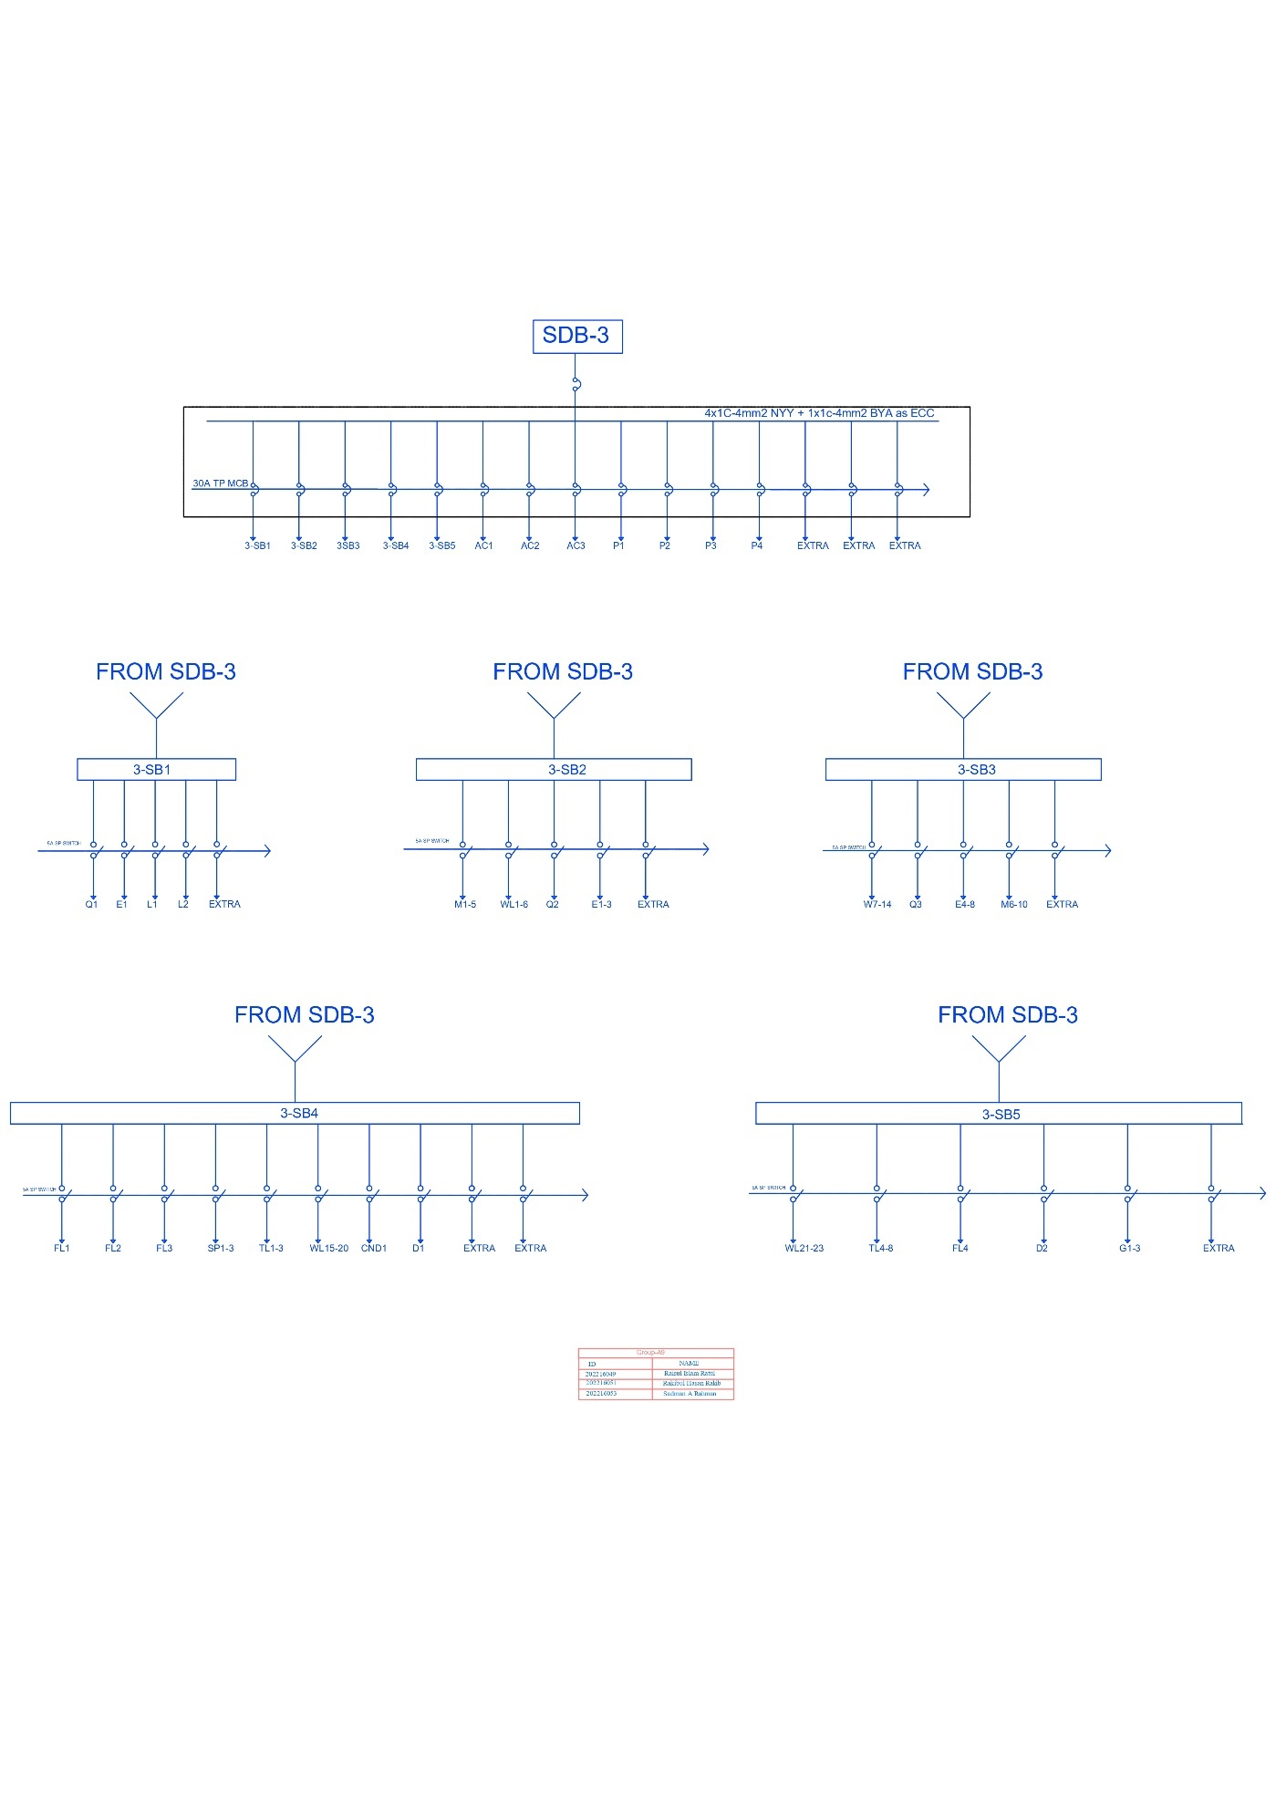
Figure 8 SDB3

Calculation:
- Load calculation.
Load Calculation for Auditorium
Distribution Board
SL no | Descripting of Items | Considered Rating(Watt) | Quantity | Total Wattage | D.F(%) | Maximum Demand (Watt)
i. | Lights
 | Circular LED Light | 60 | 30 | 1800 | 60% | 1080
 | Flat LED Light | 80 | 2 | 160 | 60% | 96
 | Wall bracket light (WL) | 40 | 5 | 200 | 60% | 120
 | Ceiling light (CL) | 40 | 2 | 80 | 60% | 48
 | 13A -3pin (type-S) | 1000 | 5 | 5000 | 60% | 3000
 | Wall Mounted Speaker | 600 | 5 | 3000 | 100% | 3000
Total Maximum Demand (Including SDB1+SDB2+SDB3) |  |  |  |  |  | 64314.1
 |  |  |  | with 10% spare |  | 70745.51
 |  | Therefore, I |  |  |  | 123.0269254
 |  |  |  | with25% of RF |  | 153.7836567
 |  |  |  | Circuit Breaker: 160A DP MCB
 |  |  |  | Cable: 4x1C-50mm2 NYY + 1x1c-16mm2 BYA as ECC
Sub Distribution Board-01
Serial No | Descripting of Items | Considered Rating(Watt) | Quantity | Total Wattage | D.F(%) | Maximum Demand(Watt)
i. | AC Loads
 | Central AC | 3000 | 11 | 33000 | 100% | 33000
 |  |  |  |  |  | 0
Total Maximum Demand |  |  |  |  |  | 33000
 |  |  |  | with 10% spare |  | 36300
 |  | Therefore, I |  |  |  | 63.12594809
 |  |  |  | with25% of RF |  | 78.90743511
 |  |  |  | Circuit Breaker: 80A DP MCB
 |  |  | Cable: 4x1C-25mm2 NYY + 1x1c-16mm2 BYA as ECC
Sub Distribution Board-02
Serial No | Descripting of Items | Considered Rating(Watt) | Quantity | Total Wattage | D.F(%) | Maximum Demand(Watt)
i. | Lights
 | Flat LED Light | 80 | 4 | 320 | 60% | 192
 | Mirror Light | 15 | 4 | 60 | 60% | 36
 | Tube Light | 40 | 5 | 200 | 60% | 120
 | Wall bracket light (WL) | 40 | 16 | 640 | 60% | 384
 | Stage Spot Light | 800 | 3 | 2400 | 60% | 1440
 | Incandescent Rotating Stage Lights | 1500 | 3 | 4500 | 60% | 2700
 | Ceiling light (CL) | 40 | 8 | 320 | 60% | 192
ii. | Fan
 | Ceiling Fan | 75 | 3 | 225 | 50% | 112.5
 | Wall Mounted Fan | 45 | 2 | 90 | 50% | 45
ii. | Power Sockets
 | 5A-2pin | 300 | 6 | 1800 | 50% | 900
 | 13A-3pin | 1000 | 5 | 5000 | 60% | 3000
iii. | AC Loads
 | AC(1.5 TON) | 1500 | 2 | 3000 | 100% | 3000
iv. | Others
 | Washroom Exhaust Fan | 36 | 4 | 144 | 60% | 86.4
Total Maximum Demand |  |  |  |  |  | 12207.9
 |  |  |  | with 10% spare |  | 13428.69
 |  | Therefore, I |  |  |  | 23.35258369
 |  |  |  | with25% of RF |  | 29.19072961
 |  |  |  | Circuit Breaker: 32A DP MCB
 |  |  | Cable: 4x1C-4mm2 NYY + 1x1c-4mm2 BYA as ECC
Sub Distribution Board-03
Serial No | Descripting of Items | Considered Rating(Watt) | Quantity | Total Wattage | D.F(%) | Maximum Demand(Watt)
i. | Lights
 | Chandelier | 400 | 1 | 400 | 100% | 400
 | Flat LED Light | 80 | 4 | 320 | 100% | 320
 | Exhibition Spot Light | 15 | 3 | 45 | 60% | 27
 | Mirror Light | 15 | 10 | 150 | 60% | 90
 | Tube Light | 40 | 8 | 320 | 60% | 192
 | Wall bracket light (WL) | 40 | 2 | 80 | 60% | 48
 | Ceiling light (CL) | 40 | 23 | 920 | 60% | 552
 | Door Light | 30 | 2 | 60 | 100% | 60
 | Security Light | 50 | 1 | 50 | 100% | 50
 | Garden Light | 40 | 3 | 120 | 60% | 72
ii | Power Sockets
 | 5A-2pin | 300 | 2 | 600 | 50% | 300
 | 13A-3pin | 1000 | 4 | 4000 | 50% | 2000
iii. | Others
 | Washroom Exhaust Fan | 36 | 7 | 252 | 60% | 151.2
iv. | AC Loads
 | Central AC | 3000 | 2 | 6000 | 100% | 6000
 | AC(1.5 TON) | 1500 | 1 | 1500 | 100% | 1500
Total Maximum Demand |  |  |  |  |  | 11762.2
 |  |  |  | with 10% spare |  | 12938.42
 |  | Therefore, I |  |  |  | 22.50000081
 |  |  |  | with25% of RF |  | 28.12500101
 |  | Circuit Breaker : 32A DP MCB
 |  |  | Cable: 4x1C-4mm2 NYY + 1x1c-4mm2 BYA as ECC

- Bus bar size, Cable size and circuit breaker size determination

Bus Bar Size Chart

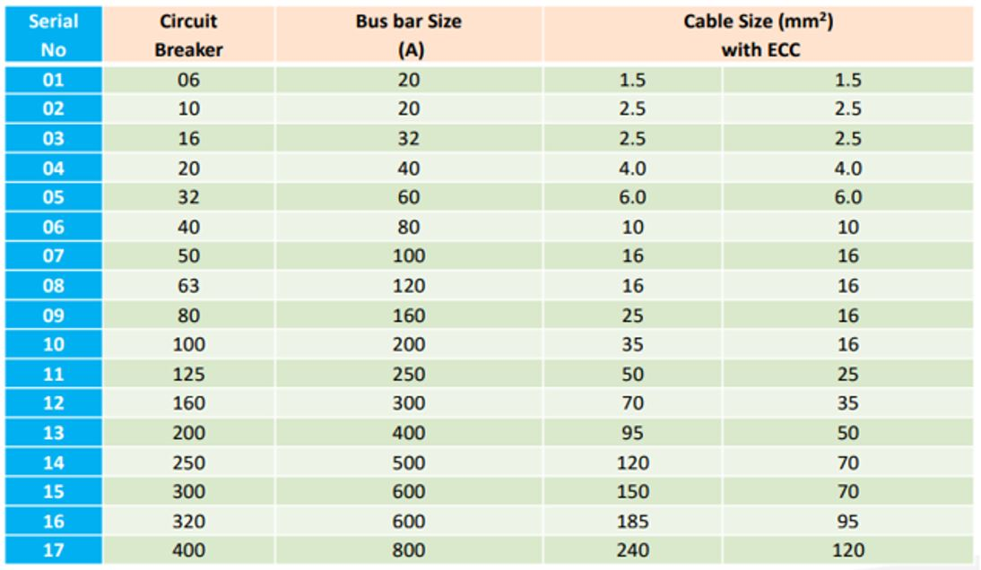
Figure 9 Bus bar chart
Bus Bar size is double than Circuit breaker

From Distribution Board to Sub- Distribution Board
From figure 9:
Circuit Breaker | Bus Bar Size(A)
160A DP MCB | 300A

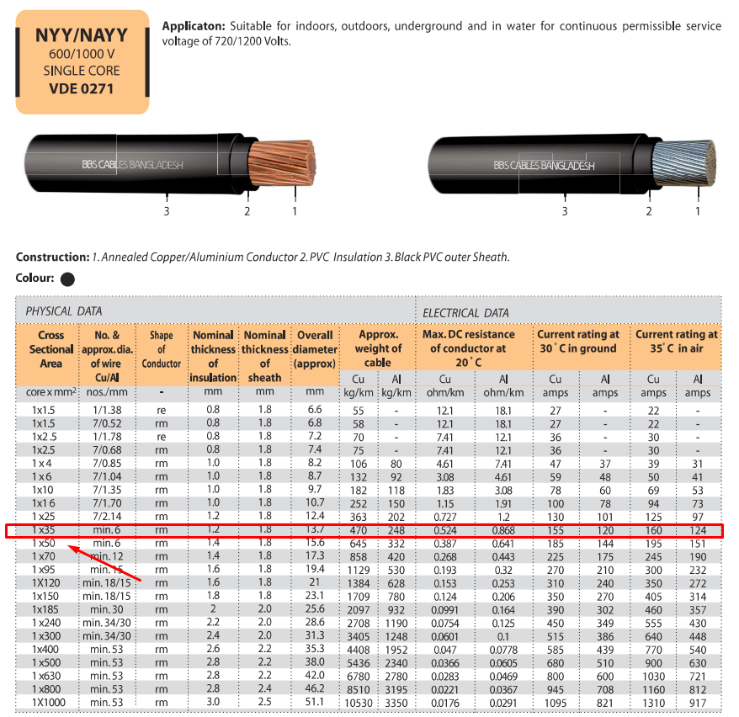
Total Maximum Demand(Including SDB1+SDB2+SDB3) | 64314.1
with 10% spare | 70745.51
Therefore, I | 123.0269254
with25% of RF | 153.7836567
Cable: 4x1C-50mm2 NYY + 1x1c-16mm2 BYA as ECC

For Sub – Distribution Board -1
From figure-9
Circuit Breaker | Bus Bar Size(A)
80A DP MCB | 160A
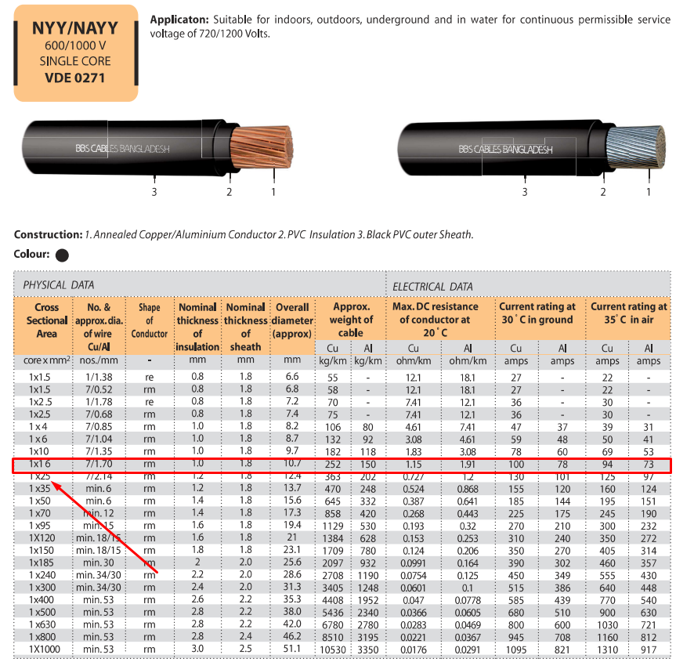
Total Maximum Demand | 33000
with 10% spare | 36300
Therefore, I | 63.12594809
with25% of RF | 78.90743511
Cable: 4x1C-25mm2 NYY + 1x1c-16mm2 BYA as ECC

For Sub-Distribution Board-2
From figure 9:
Circuit Breaker: | Bus Bar Size(A)
32A DP MCB | 60A

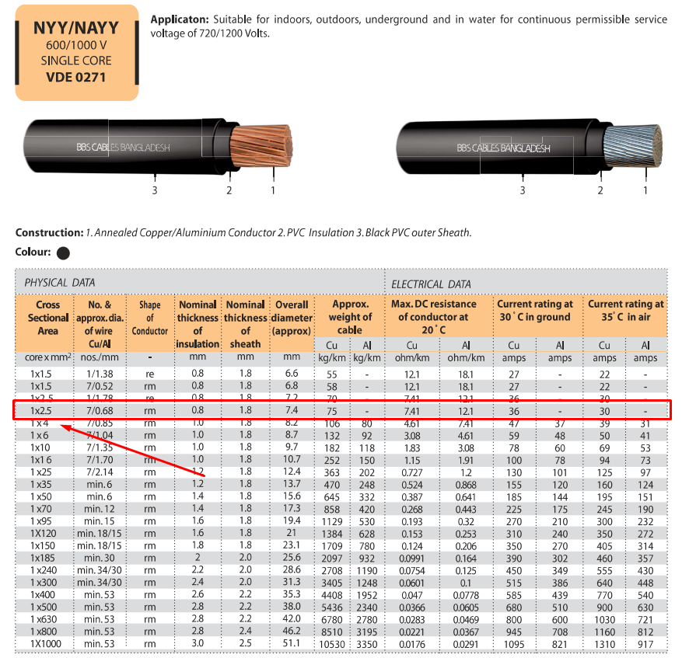
Total Maximum Demand | 12207.9
with 10% spare | 13428.69
Therefore, I | 23.35258369
with25% of RF | 29.19072961
Cable: 4x1C-4mm2 NYY + 1x1c-4mm2 BYA as ECC

For Sub-Distribution Board-03
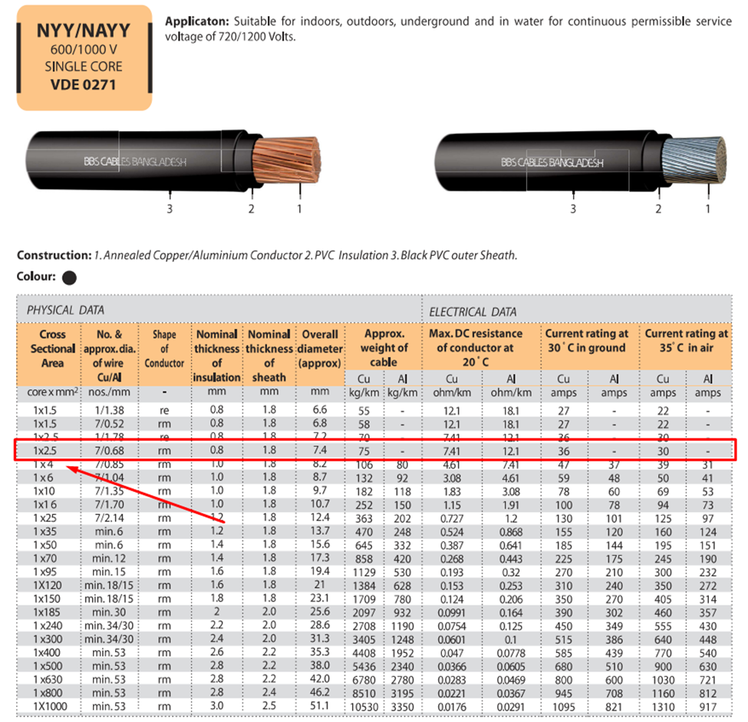
From Figure 9:
Circuit Breaker | Bus Bar Size(A)
32A DP MCB | 300A

Total Maximum Demand | 11762.2
with 10% spare | 12938.42
Therefore, I | 22.50000081
With 25% of RF | 28.12500101
Cable: 4x1C-4mm2 NYY + 1x1c-4mm2 BYA as ECC

- Illumination calculation

We have to calculate the number of light needed for main hall area.
We have,
Illuminance, E= 200
Maintenance factor, mf= 0.7
Utilization Factor, uf= 0.6
Average flux from each light, F = 2600
Length, L= 39 ft 2inch = 11.8872m
Width= 42 ft. 7 inch =13.1064m
Area= L x W = 155.59m²
$$N=\frac{EA}{F × mf × uf}$$
$$N=\frac{200 ×155.59}{2600 × 0.7 × 0.6}$$
$$=28.49≈30$$

Mounting Height, Hm = 10m
Space to Height Ratio, SHR= $\frac{1}{10}×\sqrt{\frac{155.59}{28}} =0.235$
Now,
$$\frac{s}{Hm}=0.235$$
$$s=2.4$$

Number of lights in each Row=$\frac{11.887}{2.4}=4.9≈5$
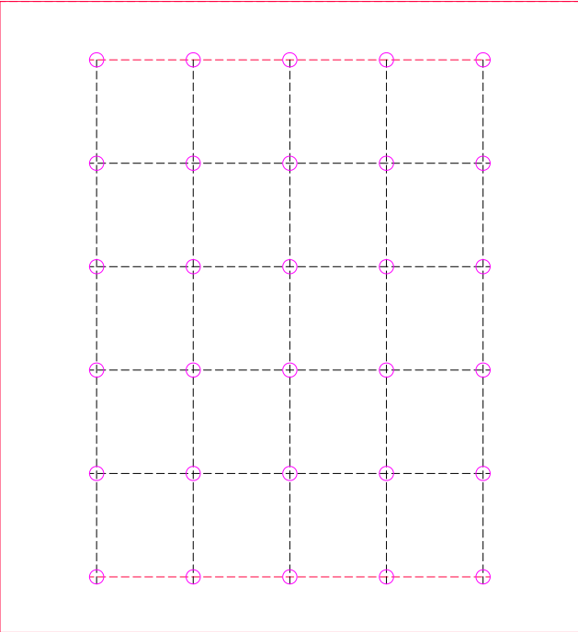
Number of lights in each Column= $\frac{28}{5}=5.6≈6$
Figure 10 Illumination Diagram

Estimation of Total Cost
BOQ Calculation for Auditorium
Item No | Description | Unit | Quantity | Unit Rate(BDT) | Total Amount
1 | Cable works
 | 4x1C-50mm2 NYY(BRB Cables) | Meter | 176 | 3,383.83 | 595,554.08
 | 4x1C-25mm2 NYY(Bizli Cables) | Meter | 1250 | 2,116.40 | 2,645,500.00
 | 4x1C-4mm2 NYY | Meter | 321 | 415.40 | 133,343.40
 | 4x1C-4mm2 NYY | Meter | 66 | 415.40 | 27,416.40
2 | Cable works (ECC)
 | 1x1c-16mm2 BYA | Meter | 180 | 196.40 | 35,352.00
 | 1x1c-16mm2 BYA | Meter | 1270 | 196.40 | 249,428.00
 | 1x1c-4mm2 BYA | Meter | 330 | 25.58 | 8,441.40
 | 1x1c-4mm2 BYA | Meter | 75 | 25.58 | 1,918.50
3 | Circuit Breakers
 | 160A TP MCCB | Each | 3 | 7,500.00 | 22,500.00
 | 80A DP MCB | Each | 15 | 1,200.00 | 18,000.00
 | 32A DP MCB | Each | 15 | 310.00 | 4,650.00
 | 32A DP MCB | Each | 14 | 310.00 | 4,340.00
 | 10A DP MCB | Each | 11 | 260.00 | 2,860.00
 | 20A TP MCB | Each | 14 | 427.00 | 5,978.00
4 | Air condition
 | Central AC | Each | 13 | 264,000.00 | 3,432,000.00
 | 1.5 TON AC | Each | 4 | 57,900.00 | 231,600.00
5 | Sound System |  |  |  | -
 | Wall Mounted Speaker | Each | 5 | 14,000.00 | 70,000.00
6 | Busbar
 | 300A (20x10)mm2 Cu Busbar | meter | 6 | 2,700.00 | 16,200.00
7 | Lights
 | Tube light (TL) | Each | 15 | 1,220.00 | 18,300.00
 | Mirror light (M) | Each | 14 | 620.00 | 8,680.00
 | Stage Spot Light(SL) |  | 3 | 11,577.00 | 34,731.00
 | Garden light (G) |  | 3 | 389.00 | 1,167.00
 | Door Light(D) |  | 2 | 189.00 | 378.00
 | Exhibition Spot Light (SP) |  | 3 | 621.00 | 1,863.00
 | Flat LED Light (FL) |  | 10 | 2,400.00 | 24,000.00
 | Ceiling light (CL) |  | 35 | 1,450.00 | 50,750.00
 | Stage Light(StL) |  | 3 | 17,500.00 | 52,500.00
8 | Fans
 | 1440 mm2 cealing fan | Each | 4 | 2,000.00 | 8,000.00
9 | Sockets
 | 3 Pin 13 A socket | Each | 10 | 375.00 | 3,750.00
 | 2 pin 5A socket | Each | 13 | 35.00 | 455.00
10 | Switch’s
 | 1 way 4 gang 10A switch | Each | 156 | 400.00 | 62,400.00
11 | Conduit
 | Minimum inner Dia. 20 mm & minimum wall thickness 1.5 mm. | meter | 1426 | 40.00 | 57,040.00
 | Minimum inner Dia. 25 mm & minimum wall thickness 1.5 mm. | meter | 421 | 55.00 | 23,155.00
 | Total Cost |  |  |  | 7,852,250.78

By performing these calculations diligently, one can accurately determine the electrical load, specify the required electrical components, design appropriate lighting systems, and provide a reasonable estimation of the total cost for an Auditorium construction project. Professional consultation and adherence to relevant electrical standards are crucial throughout these processes for accurate and safe installations.

Conclusion:
The Auditorium's floor plan exemplifies a harmonious convergence of efficiency, suitability, and cost-effectiveness, crafting a versatile space designed to cater to diverse events while emphasizing functionality and economic viability.
Careful planning and layout orchestration of the main hall, stage area, technical booths, and ancillary rooms ensure a seamless experience for presenters and audiences while meeting safety and accessibility standards. This thoughtful arrangement optimizes event operations, ensuring optimal visibility, acoustics, and technical support.
Efficiency is deeply ingrained in the design's core. Precise load calculations and selection of electrical components guarantee an efficient system meeting demand loads and allowing for future expansions. Additionally, the lighting design, meticulously calculated to fulfill requirements while conserving energy, underscores the Auditorium's sustainability.
Cost-effectiveness is evident through prudent material selection, labor estimation, and project management. The design strikes a balance between functionality and economic feasibility, utilizing resources efficiently.
In summary, the Auditorium's floor plan harmonizes appropriateness, efficiency, and cost-effectiveness, serving as a model for versatile and economically feasible architectural designs.

Reference:
- Bizli Cable Price List 2023 in Bangladesh - Price Alert (pricealertbd.com)
- https://www.bbscables.com.bd/
- Daraz.com.bd
- https://www.amazon.com/s?k=interconnect+cable&i=mi&adgrpid=1341405421214378&hvadid=83838119638142&hvbmt=bp&hvdev=c&hvlocphy=141986&hvnetw=o&hvqmt=p&hvtargid=kwd-83838675490925%3Aloc-12&hydadcr=19108_13418961&tag=mh0b-20&ref=pd_sl_6p1aqgtufl_p
- The Ultimate Guide to Auditorium Lighting (ledlucky.net)

